H2 GLOBAL LINKS DOC REV 2.0
H2 GLOBAL LINKS TO MEDIA (C) H2 GLOBAL 2012-19 , ALL RIGHTS RESERVED.
Please pass this around freely. Help us get the word out. Thank you.
PERMISSION GRANTED FOR USE BY THOSE POSITIVELY SUPPORTING OUR TECH AND CONTENT. FOR THOSE WHO TROLL, NEGATIVELY REPORT, LIE, PROPAGANDIZE, OR EXPOUND OPINIONS CONTRARY TO OUR FINDINGS, TESTS, TECHNOLOGY OR MEDIA CONTENT, ALL RIGHTS ARE PROHIBITED AND RESTRICTED FOR ANY USE.
H2 Global, LLC is a Florida based company near Tampa Fl. We currently use three websites, all are supposed to goto the same web pages, if any trouble reaching our web site, please use one of the other web links H2GE.COM H4GAS.COM H2-GLOBAL.COM ( must use hyphen in this one )
If these links don’t access the website from this document, cut and paste the link into your browser ( be certain when copying not to get an extra space on either end of copied link, or it may not work )
When using these links, if propted for a password, hit cancel on the prompt, it should then load ok
If any trouble please contact us at:
cyberstreme@msn.com or H2GE@protonmail.com thank you.
-------------------------------------------------------------------------------------------------------------------------------------
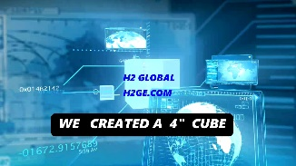
30 SEC SPOT “4 INCH CUBE” https://1drv.ms/v/s!Auc_8BQQg3azkTixycNSCb7bxh4M
-----------------------------------
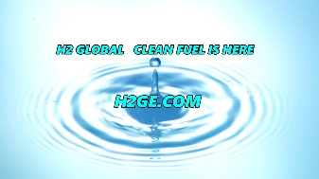
30 SEC SPOT “H2 Global clean fuel is here “ https://1drv.ms/v/s!Auc_8BQQg3azkT3d_CUHeGfUvNCC
-------------------------------------
Link to “ A NEW SOLUTION” 2MIN VIDEO” announcing the H2 GLOBAL technology breakthrough 2019
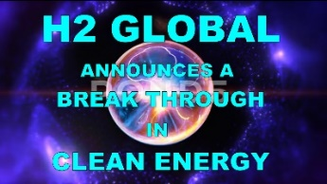 https://1drv.ms/v/s!Auc_8BQQg3azkSVnUSzRp8QZwNhJ
Link to “TEST STAND H2G CLEAN FUEL V. GASOLINE made 2019
----------------------------------------
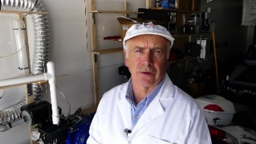 https://1drv.ms/v/s!Auc_8BQQg3azkTFdD-kUc3eJRl7k?e=6DtCro
TEST STAND ENGINE TEST H2G CLEAN FUEL VS GASOLINE 2019
-----------------------------------------
https://1drv.ms/v/s!Auc_8BQQg3azkUFYqDl4VQuGRmR-
- MINUTE VIDEO SHOWING H2G TECH AS OF 2016 ( MUCH CHANGED AND UPDATED SINCE THEN )
---------------------------------------------
https://youtu.be/Y2-V_FlXtOU
“FLYAWAY” INTERVIEW WITH WALT 2015 ?
-------------------------------------------------
Energy & Science conference Hayden Idaho, 2017 panel discussion
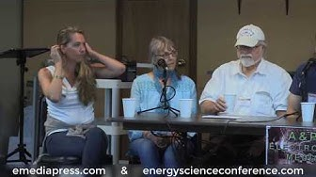 https://www.youtube.com/watch?v=sySTt9XhQpY

Articles on H2G TECH
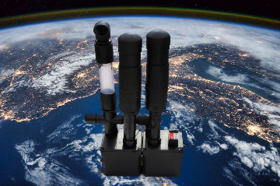 https://1drv.ms/b/s!Auc_8BQQg3azkUInJMd9sJ5LbLQB
Can this BLACK BOX CHANGE THE WORLD ? 2017-19, ARTICLE

H2 GLOBAL DOCUMENTS NDAs DEMONSTRATION APPLICATIONS INVESTOR INFO, ETC.
NDA 2019 https://1drv.ms/w/s!Auc_8BQQg3azkUWKerzQRkIimyHY
3 PAGE BIZ STRATEGY SUMMARY https://1drv.ms/w/s!Auc_8BQQg3azkUZqXlaFYbAOgsX-

H2G COMPANY BROCHURES
GRID POWER CONCEPTS https://1drv.ms/b/s!Auc_8BQQg3azkUK5n73Lg_LACwXD
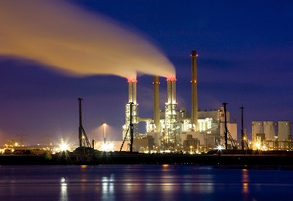 (UTILITY POWER COMPANY INFO)

H2G RADIO INTERVIEWS, RICHARD C HOAGLAND THEOTHERSIDEOFMIDNIGHT.COM
https://www.theothersideofmidnight.com/2018-05-05_walterjenkins/
https://content.streamhoster.com/preview/osom/osom/Jenkins_HyperdimensionalMachines_AndTheMadmenWhoCreateThem_2019-04-06_OSOM.mp3?width=640&height=35&showPlayBtnOverlay=0&controlBarAutoHide=0

https://eur03.safelinks.protection.outlook.com/?url=https%3A%2F%2Fcontent.streamhoster.com%2Fpreview%2Fosom%2Fosom%2FHOLEY-WATER2_Bohdy_Jenkins_King_Thorp_Saunders_2019-03-31_OSOM.mp3%3Fwidth%3D640%26height%3D35%26showPlayBtnOverlay%3D0%26controlBarAutoHide%3D0&data=02%7C01%7C%7Cb339a8a898c3434d409e08d6be4ddadb%7C84df9e7fe9f640afb435aaaaaaaaaaaa%7C1%7C0%7C636905638920566682&sdata=07DwiDyYWv6VfCX%2BUwONvt4T5a5yV%2FFP1GOOwJTtvlk%3D&reserved=0

Books on H2G TECH BELOW. Also, Listen to Moray King’s lecture , about 1 hr in he goes into details
on H2G TECH see video here: https://youtu.be/WiYNwFLDjfg
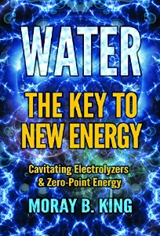 Buy this book on amazon for a better understanding of H2 Global’s technology
Moray B Kings Book “Water the new energy”
https://www.amazon.com/WATER-ENERGY-Cavitating-Electrolyzers-Zero-Point-ebook/dp/B078RYBJMY/ref=sr_1_1?keywords=moray+king&qid=1555870273&s=gateway&sr=8-1

