H2 GLOBAL, LLC, PO BOX 1673, ANNA MARIA FLORIDA [ 34216 ]
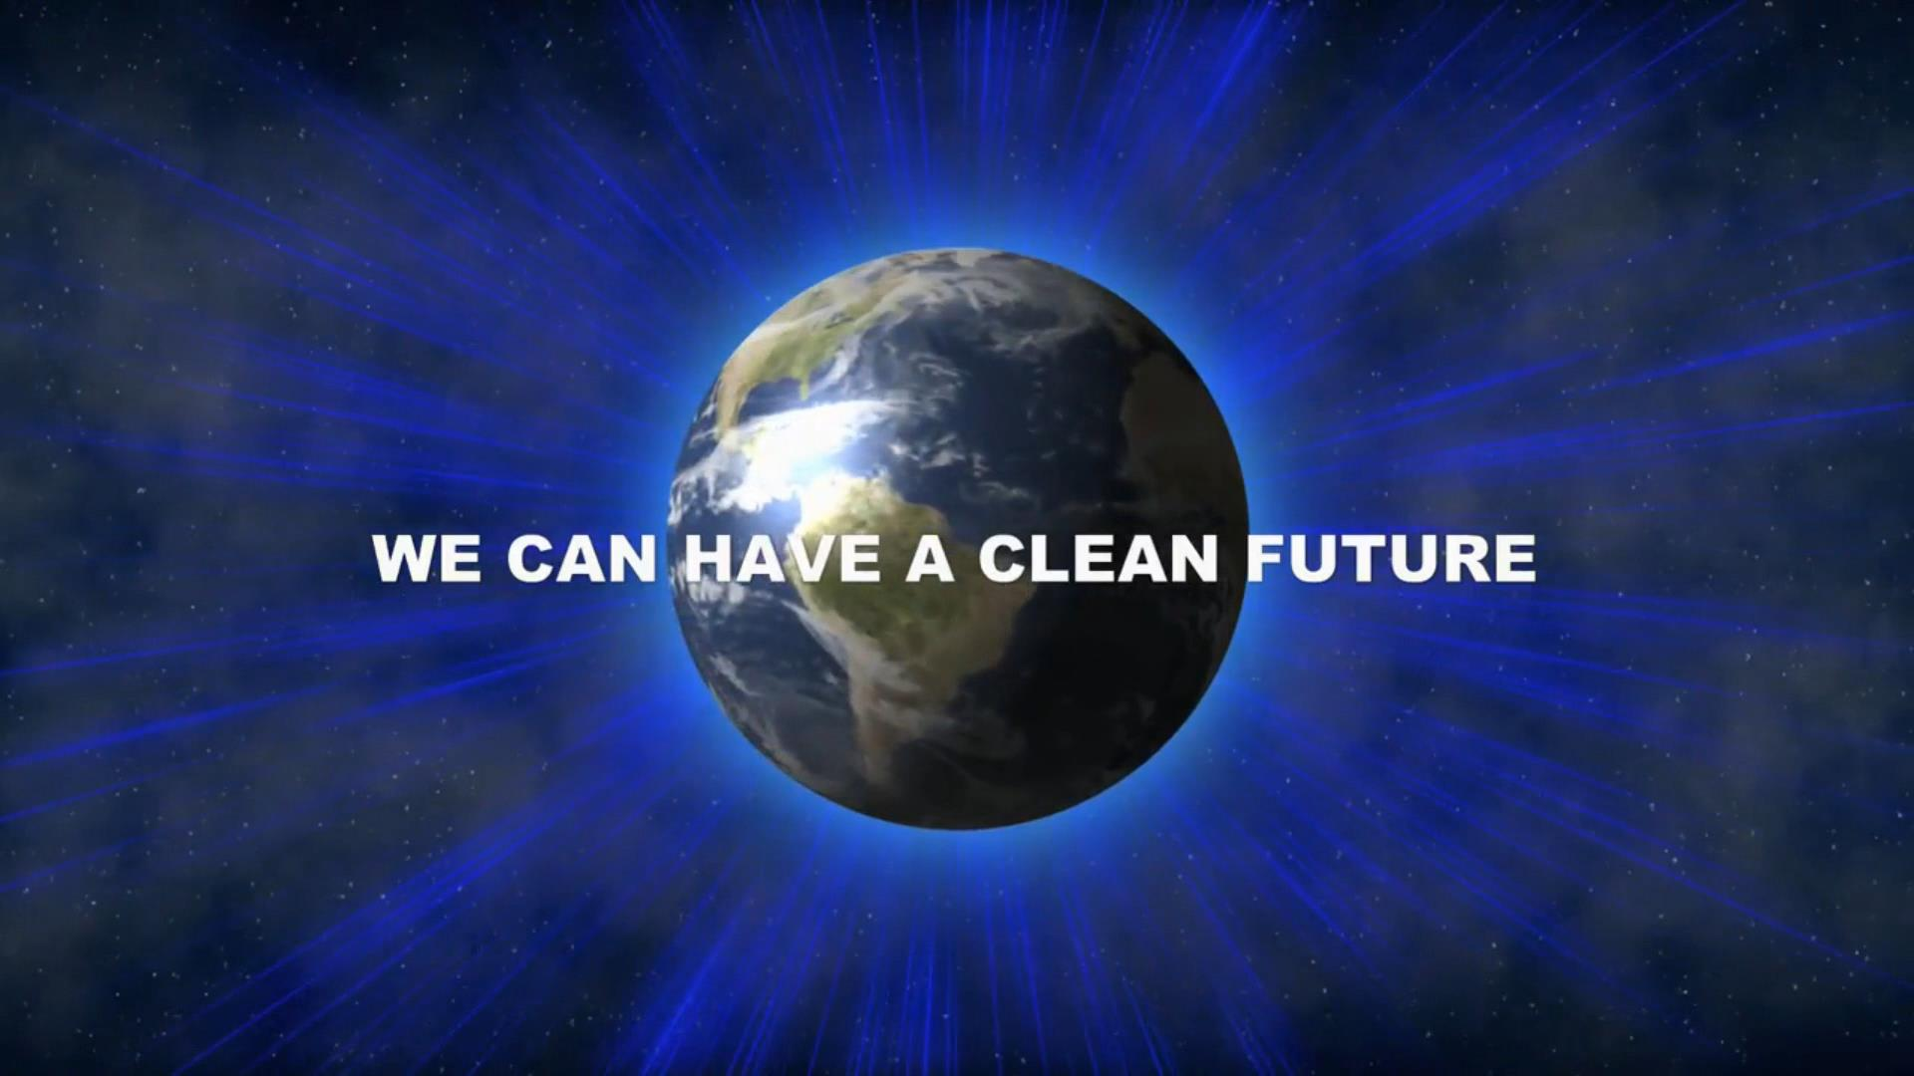 H2GE.COM 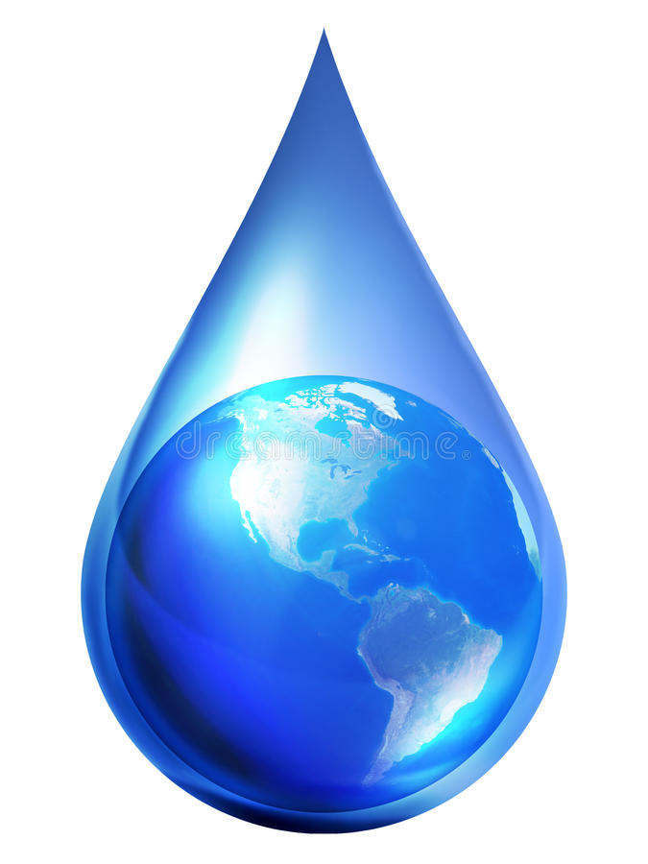

DEMONSTRATION APPLICATION

Thank you for your inquiry. Due to a large number of inquiries, H2G requests that each applicant provide the following information. We apologize if you consider this measure intrusive, however, some of our research is for international and government projects. Background checks are made on all applicants. Your coopearation is greatly appreciated.
What is your full name? _____________________________________(age)____DOB_______________
What is your email?_________________________________________ Cell Number________________
How did you become aware of H2G technology?____________________________________________
What is your reason for a demonstration?_______________________________________________
Are you an Acredited investor? Yes_____ No______( i.e. $200k annual income and 1 million in assets )
Are you considering an investment? Yes _____No_____? Would you like offering docs? Yes____No___
Are you an Engineer ? Yes____No______ ( If yes what discipline? )____________________________
What is your Highest degree? _______(yr)______From which Institution ?________________________
Please list your current or last employer?__________________________________________________
All parties attending must file an application before demonstration appointments are approved.
Please include a copy of your Drivers License or government approved I.D.
There is a $500 fee ( covers up to 5 people) for background checks on all participants applying, staff, security and other expenses related to demonstrations. ( Payable in advance ).
H2 Global, LLC is involved in government projects. Restrictions on certain disclosures apply. Background checks are required.
Each party is required to sign an NDA prior to attending demonstrations. I agree. Yes _____ No_____
Please indicate all dates you are available for a demonstration? ( 10 am- 6pm eastern USA )
____________________________________________________________________________________
Signature Date

